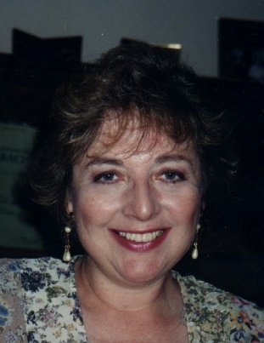
Sally-Ann Jacobsen was born January 3, 1939, to Clarence and Mary Elizabeth Heimbigner, older sister to Lewis and Joan. Sally died October 16, 2020, at home with Claire at her side. Sally is survived by her caregiver daughter Claire Jacobsen, son Hans Jacobsen (Michelle), granddaughter Danielle Jacobsen, sister Joan Nye (Jerry), sister-in-law Pat Weiss, niece Tamara (Gary), niece Brenda (Rob), special cousin Paula, and many good friends and relatives.
A marvelous pianist, Sally won Starlit Stairway, the Washington statewide televised youth talent competition. She was Valedictorian of Odessa High School Class of 1957. At Whitman College she joined Alpha Chi Omega sorority and earned her BA in English Literature. In 1961 she and Whitman classmate Gerald Jacobsen married and moved to Purdue University, where Sally earned her Ph.D in English literature.
Sally taught at four colleges, including 20+ years at Northern Kentucky University where she became a tenured professor. She was an active member of the Modern Language Association (MLA) and Margaret Atwood Society. Over the years Sally published numerous papers, chaired many discussions at the annual MLA conference, and served several years as Margaret Atwood Society President. After retirement Sally has lived in Albuquerque since 2008 and been an involved member of First Unitarian Church Albuquerque. She loved to read and was in several book groups, usually six or more at any one time. Sally traveled to spend time with family and friends, including lifelong Odessa friends, and she had a wide circle of former students and colleagues with whom she kept in close contact. She loved attending Santa Fe Opera with various friends.
With failing health in late 2019 Sally wrote: “my situation has led me to re-think my values with regard to quality of life. I think of victims of violence in the world and wonder how effective individuals can be in curbing such violence. With so many countries visiting violence on their citizens and others, it seems futile for a distant country to have a kindly effect on other peoples. We often have admired leaders who focus on power, but I think it is time to focus instead on compassion for individual human beings. I crave a gentler approach than people or governments today seem to practice in their actions. We have admired the warrior class and its accomplishments through history, but perhaps the more feminine, caring virtues would help humanity far more.”
The family suggests memorial donations be made to Sally’s church or to public radio: (1) First Unitarian Church of Albuquerque, 3701 Carlisle Blvd. NE, Albuquerque, NM 87110; (2) *KUNM MSC06 3520, 1 University of New Mexico, Albuquerque, NM 87131-0001.
*Note: on Sat, Nov 28, 2020, Claire heard on public radio KUNM: “This program of The Children’s Hour is dedicated to Sally Jacobsen, Professor of Literature,” undoubtedly due to memorials for Sally.

I want to be sure you know about Sally’s death before you send your holiday letters. I am happy to answer any questions.

Sincerely, Sally’s sister, Joan Nye joannyeootd@gmail.com 406-321-0591

