The Aphra Behn Society
for Women in the Arts, 1660-1830
is pleased to announce its 2015 biennial conference
Women in the Global Eighteenth Century
November 5-6, 2015
Seton Hall University, South Orange, N.J.
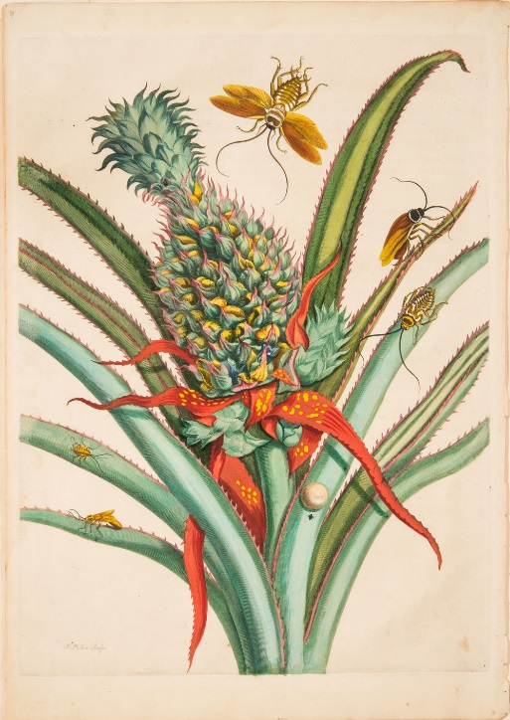
Maria Sibylla Merian, Plate 1 from Dissertation in Insect Generations and Metamorphosis in Surinam, 1719.
Used with permission of the National Museum of Women in the Arts, www.nmwa.org

Plenary lecture by Dr. Lynn Festa, Associate Professor of English,
Rutgers University

In The Global Eighteenth Century, Felicity Nussbaum and her contributors urged scholars to see the eighteenth century as “wide”: a period with a geographical as well as temporal sweep. Such a perspective, Nussbaum contended, would require different, more complex narratives of the people, events, systems, and discourses of the age. In the spirit of our namesake Aphra Behn, whose poetry, drama, plays, and translations reflect a complex awareness of a widening world, The Aphra Behn Society for Women in the Arts, 1660-1830 takes up the challenge posed by The Global Eighteenth Century to invite papers exploring any aspect of women and the arts in this “global eighteenth century.” How does a wider, potentially global, lens change the view of people, places, and things both familiar and strange, domestic and imperial, Us and Other? How does gender affect those views?
The Aphra Behn Society for Women and the Arts invites papers addressing the intersection of gender and the global eighteenth century from a wide variety of disciplines, including but not limited to Literature, History, Art History, Music History, Modern Languages, Philosophy, Religious Studies, and Women and Gender Studies. We welcome papers on this topic from all sub-fields of these disciplines.
Papers might address the following topics:
- Investigations or representations of “difference” in literature and the sister arts
- Representations of social and political authority
- The arts, women, and empire
- Women and the construction of literary, artistic, domestic, public, national, imperial, and colonial spaces
- Women and travel writing
- Women and diaspora
- Women and the metropole
- Women and indigenous knowledge
- Women, genre (textual, visual, musical, etc.), and space/place
- Notions of performance and gender
- Notions of gender and race, class, religion, or other markers, perhaps under pressure in a widening context
- Gender and encountering the Other
- Women, modernity, and post-colonial situations
- Women and the colonial or post-colonial Enlightenment

As always, we also welcome abstracts for papers not related to the conference theme.

Please upload 1-2 page abstracts or panels to http://blogs.shu.edu/abs2015/ by May 15, 2015.

In addition, the Society and its journal, ABO are sponsoring a pre-conference Wikipedia Edit-a-Thon on Wednesday, November 4th, from 12:00-5:00 pm at the Grand Summit Hotel. Participation is free and open to everyone, although participants must supply their own laptops. Registration for this event is on the conference registration form.

The registration fee includes all conference events, including the Wikipedia Edit-a-thon, the luncheon, the concluding banquet, a performance by Seton Hall students, and a reception with the rare books librarians and university archivists to view highlights of the university’s collection. The Society also sponsors a graduate student travel award ($150) and a graduate student essay prize ($150 and the possibility of publication in ABO: Interactive Journal for Women in the Arts, 1640-1830). For more information, see the conference website at http://blogs.shu.edu/abs2015/ or contact the conference organizers, Dr. Kirsten Schultz at Kirsten.schultz@shu.edu or Dr. Karen Gevirtz at Karen.gevirtz@shu.edu.

Sponsored by the Aphra Behn Society for Women in the Arts, 1660-1830, the College of Arts and Sciences, and the Women and Gender Studies Program at Seton Hall University.

