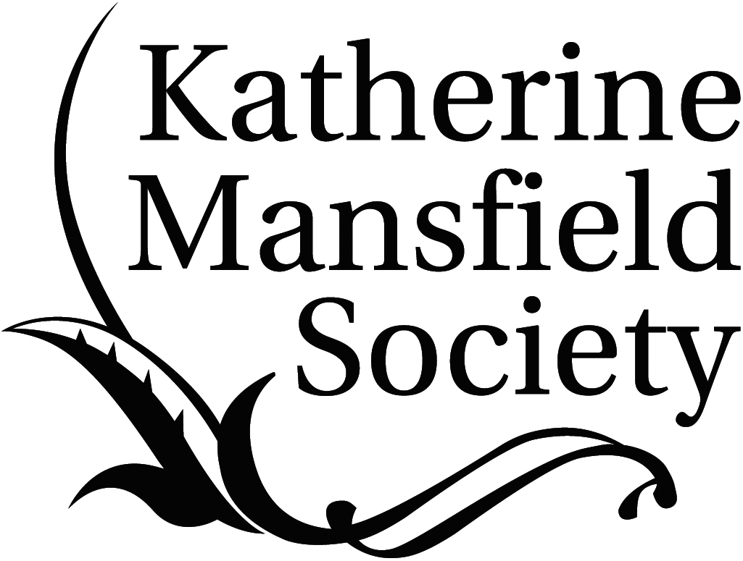

Patron: Dame Jacqueline Wilson

CALL FOR SUBMISSIONS FOR VOLUME 7 OF

Katherine Mansfield Studies

(THE PEER-REVIEWED YEARBOOK OF THE KATHERINE MANSFIELD SOCIETY)

KATHERINE MANSFIELD AND TRANSLATION

Guest Editor: Professor Claire Davison (Sorbonne Nouvelle, Paris)

Two books to be published in 2014: Volume 3 of the Edinburgh Edition of the Collected Works of Katherine Mansfield – The Poetry and Critical Writing, edited by Gerri Kimber and Angela Smith, and Translation as Collaboration: Virginia Woolf, Katherine Mansfield and S.S. Koteliansky by Claire Davison, both reveal the extent to which Katherine Mansfield devoted much of her energy to the processes of translation. In addition, Mansfield’s own books have been translated into many different languages, with new versions appearing all the time – the latest being a Slovakian edition of her stories translated by Janka Kascakova.

This volume seeks papers that address all aspects of Katherine Mansfield and translation. Topics might include, but are not limited, to:

- Mansfield as translator
- Translating Mansfield
- Transformative effects of Mansfield in translation
- Mansfield reading translations
- Reading Mansfield in translation
- Mansfield’s translators
- Mansfield from a translation theory perspective
- Mansfield and her translation collaborators

Submissions of between 5000–6000 words (inclusive of endnotes), in Word format and using MHRA style formatting, should be emailed to the Guest Editor for this volume, Professor Claire Davison, accompanied by a 50 word biography: kms@katherinemansfieldsociety.org

A detailed MHRA style guide is available from the Katherine Mansfield Society website:
http://www.katherinemansfieldsociety.org/yearbook-katherine-mansfield-studies/

CREATIVE WRITING

Pieces of creative writing on the general theme of Katherine Mansfield – poetry, short stories, etc., should be sent to the editors, accompanied by a 50 word biography: kms@katherinemansfieldsociety.org

DEADLINE FOR SUBMISSIONS: 31 August 2014

Editors: Dr Gerri Kimber, Professor Todd Martin and Dr Delia da Sousa Correa
Reviews Editors: Dr Melinda Harvey and Dr Kathryn Simpson
Editorial Assistant: Louise Edensor

