**SPECIAL BONUS PRESENTATION!**

**2014 North Central Aquaculture Conference**

***The First Commercial Use of RNA-interference Technology in Production of All-Male Prawns***

***Assaf Schechter, PhD***

***Founder & CEO***

***Enzootic, Ltd.***

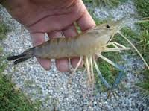

***Saturday, February 22, 2014***

***4:00 PM – 4:40 PM***

***Pine Room***

***UTMC Hotel***

***Toledo, Ohio***

Conference Registration

http://ohioaquaculture.org/events.html