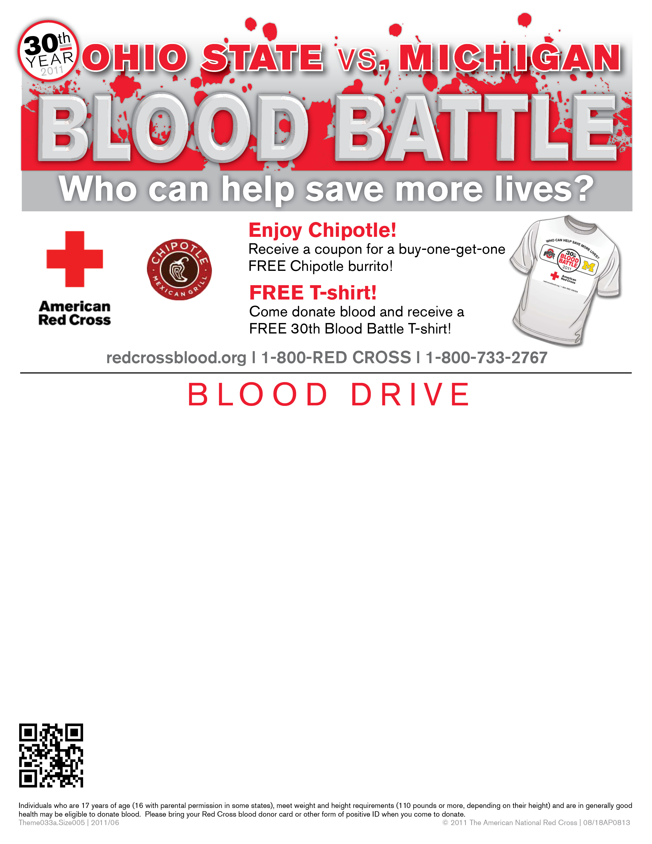

Department of Physics

Physics Research Building- Atrium

Thursday, November 10

10:00am-4:00pm
Michigan has won the battle the past three years,
encourage your friends to donate and
LET’S BEAT MICHIGAN!

Enter to win a pair of tickets to the OSU-Michigan game!

Schedule an appointment today!
redcrossblood.org l 1-800-RED CROSS
(Sponsor code: Buckeyes)
Text BLOOD to 45995 to receive blood supply and promotion updates!
If you donated on or before 9/15 you may be eligible to donate.

