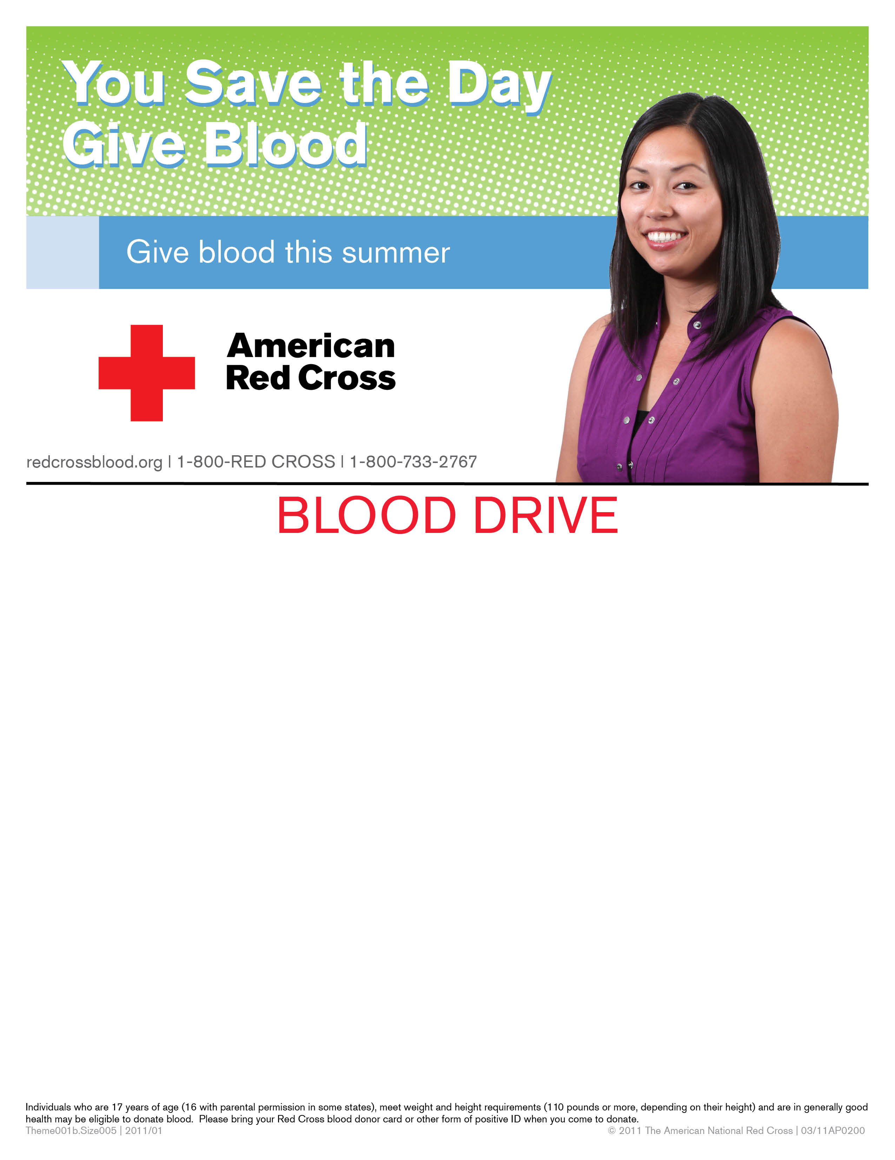
OSU Department of Physics
Atrium
SUBWAY FOR BLOOD DONORS

Tuesday, August 2
10 AM – 4 PM

To schedule an appointment call 1-800-RED CROSS or
visit www.redcrossblood.org sponsor code buckeyes.

Enter to win FREE GAS for a year plus one of 8 $50
gas cards from Marathon. Get a Buy One Get
One free entry coupon to the Columbus Zoo.
Register for donor rewards at redcrossracing.com.

If you last donated on or before June 7, you may be eligible to give.

