**NCH Sealant Protocol Version 2.24.17**

**Situation:**

* Multiple providers, some new, performing sealants on children within NCH Dental Clinic with no specific protocol.
* Instances of children coming for separate EFDA Sealant and Resident CC appointments when scheduling could be more efficient.
* Non-retained sealants at 6 month recall visits, even after introduction of Isovac.

**Background:**

A systematic review found that sealants reduce the incidence of decay in children by 80% compared to children who do not receive sealants, though sealants are an underutilized prevention mechanism. Sealants are more effective than fluoride varnish alone in occlusal grooves and are effective in arresting decay in non-cavitated lesions. Sealants have been reported to have no adverse outcomes, and the risk of BPA exposure is low.

*-Wright, John T. et al. Sealants for preventing and arresting pit-and-fissure occlusal caries in primary and permanent molars: A systematic review of randomized controlled trials—a report of the American Dental Association and the American Academy of Pediatric Dentistry. The Journal of the American Dental Association, Volume 147, Issue 8, August 2016, Pages 631-645.e18*

*-Wright JT et al. Evidence-based clinical practice guideline for the use of pit and fissure sealants. AAPD, ADA. Pediatr Dent 2016;38(5):E120-E36.*

Ohio Medicaid (2016) <http://codes.ohio.gov/pdf/oh/admin/2017/5160-5-01_ph_ff_a_app1_20160921_1537.pdf>

* Coverage is limited to patients younger than 18.

Pit and fissure sealant may be applied to previously unrestored areas of permanent first and second molars. *[Thus, if you restore #19-B with composite, apply sealant afterwards to #19-OB, you may bill for both #19-B composite and #19-O sealant]*

Reimbursement: $22 per tooth, $0 for re-sealing

Caresource Manual (2016) <https://www.caresource.com/documents/oh-p-24-dental-handbook/>

Pit and fissure sealants are covered on previously unrestored occlusal areas of permanent molars subject to the following limitations:

* Permanent first molars and on permanent second molars for patients under the age of 18.
* **Sealants are covered every two years.**

Molina Manual (2016) <http://www.molinahealthcare.com/providers/oh/medicaid/manual/PDF/oh-dental-manual.pdf>

* One D1351 per patient per tooth per lifetime.

Private insurance coverage will vary but most cover permanent first and second molars. We bill $52.25 per sealant.

Sealants not reimbursed (but often sealed):

* Premolars
* Primary molars
* Linguals of anterior teeth
* Re-seals

These teeth are not reimbursed but should be coded, billed, and will be written off by NCH if not reimbursed.

Who can place sealants in Ohio?

* Dentist
* Dental Hygienist
* Dental Assistant with Sealant Certification
* EFDA

**Assessment:**

With a new protocol, we can better utilize clinic personnel and resources to provide better sealants for more patients.

**Recommendation:**

Indications:

* Permanent 1st and 2nd molars with grooves at risk of caries.
* Teeth should be fully erupted with access to distal grooves, lingual pits, and buccal pits. Partially erupted teeth should be planned for sealants only with Attending approval.
* Teeth must be able to be isolated, taking into account patient cooperation and anatomical considerations. For some children, it will be better to defer sealants until after their next hygiene appointment in order to gain more cooperation and maturity, and thus place better sealants.
* Unrestored grooves, even on partially erupted teeth, during any type of GA procedure.
* Sealants have been found to arrest decay in non-cavitated lesions. Teeth are to be treatment planned as either sealants (D1351) when caries has not caused cavitation or composites (D2391) when decay has caused a cavitation. Radiographic interpretation should precede sealant placement. In the case of incipient interproximal caries, or non-cavitated occlusal caries, the dentist should document that caries was detected and the indication for sealant placement. The term “open and seal” should no longer be used nor treatment planned. Grooves showing signs of decalcification should be sealed and not opened. Opening a groove for exploratory purposes has potential to cause sealant failure and later need for restoration. If a groove needs to be “opened” this means the patient has a cavitation and thus needs a restoration (for example, composite or amalgam) and the patient should be scheduled for a CC visit.

Special Considerations – require approval of an Attending prior to scheduling

* Teeth at high risk for caries where conventional sealants cannot be placed (partially erupted teeth, special needs patients) may benefit from transitional sealants using a resin-modified glass ionomer under approval of an Attending.
* Patients at high risk of caries on these surfaces:
  + Deep pits or grooves of anterior teeth (ex: upper laterals)
  + Deep or stained grooves of primary teeth in a patient with history of occlusal caries
  + Premolars
  + *See “Scheduling” section below.*

Below are examples of teeth which can **all be sealed** (whether sound or incipient or white spot lesions).

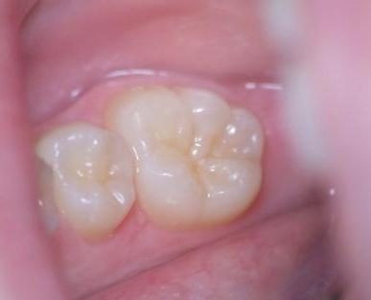 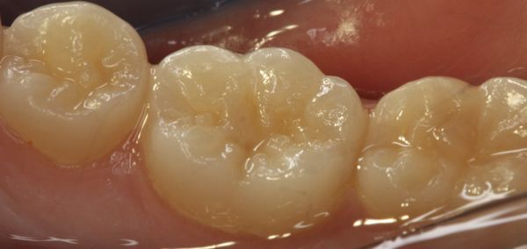

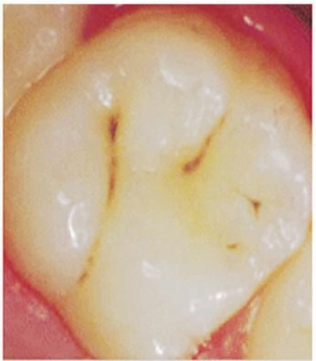 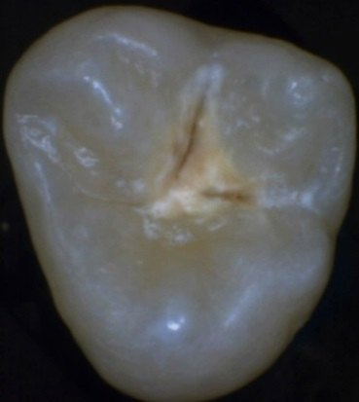 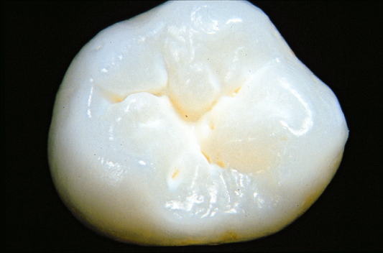

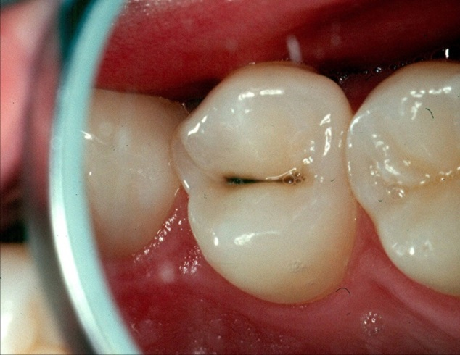 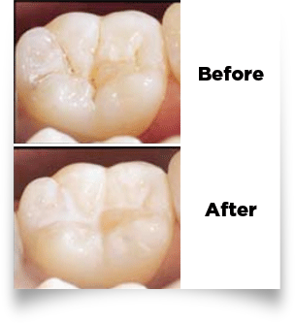 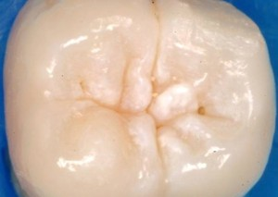

Contraindications:

* Uncooperative or anxious patients – *“Never make the treatment worse than the disease.”* Children should not be moving or crying while getting sealants.
* Flat grooves in patients at no or low risk for caries.
* Primary teeth or premolars in a patient with no caries history.

Clinical procedure: <http://www.ivoclarvivadent.com/en/products/prevention-care/fissure-sealing/helioseal-f>

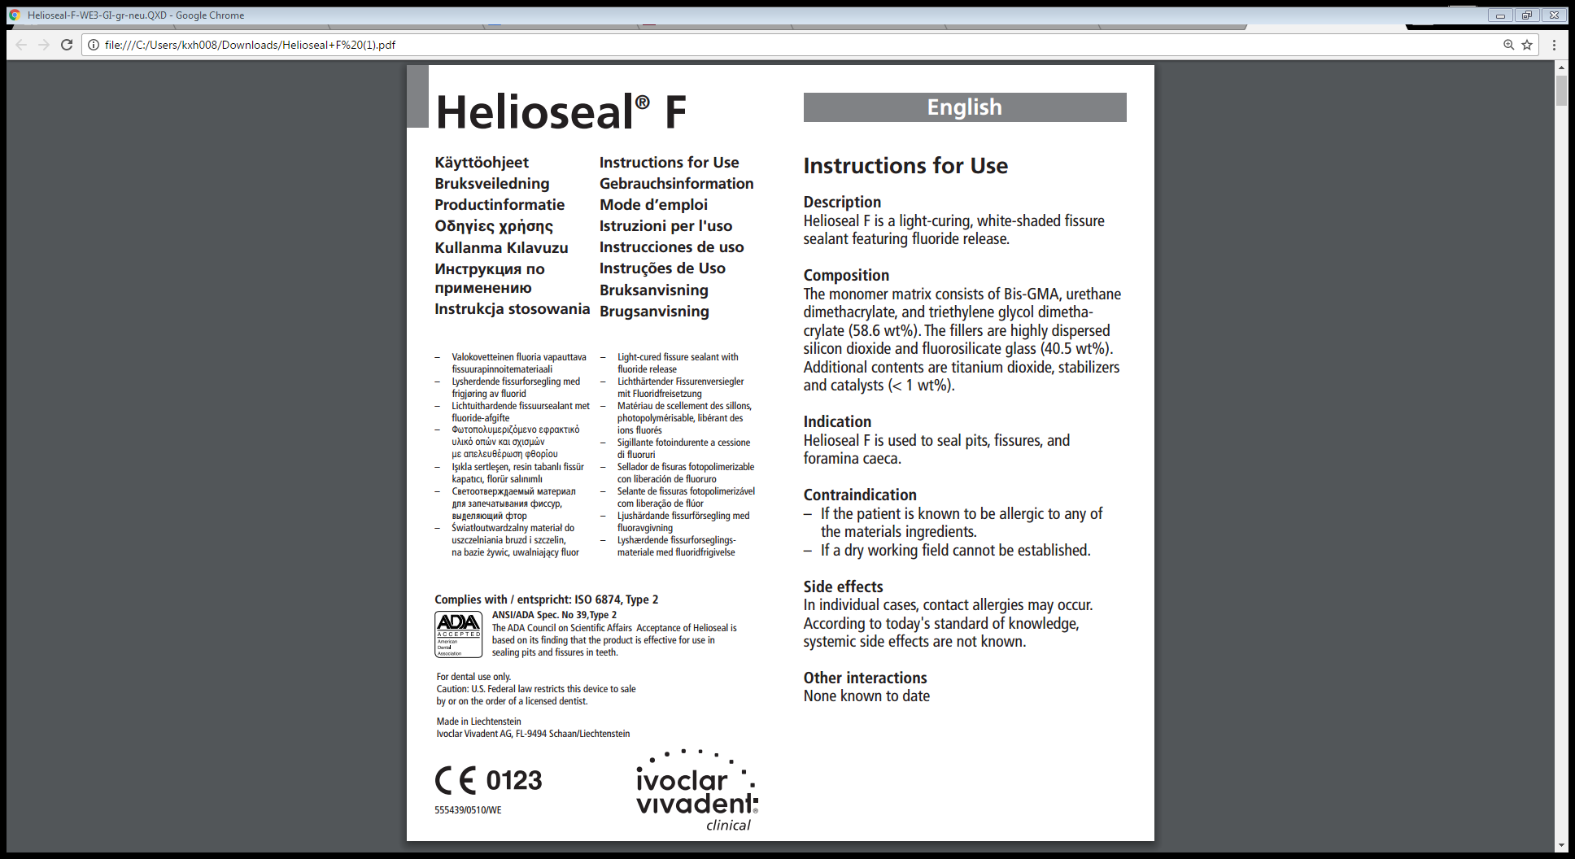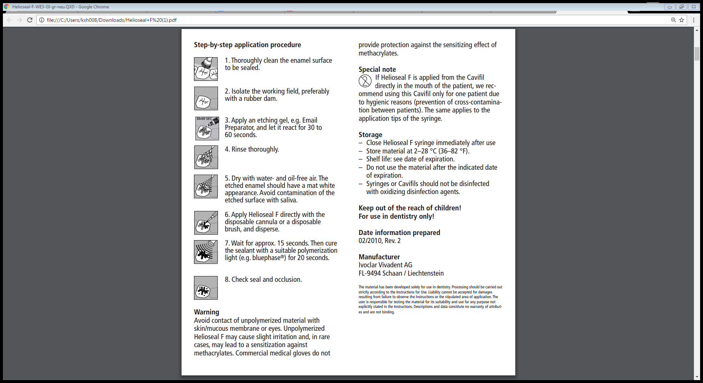

Materials:

Hygiene handpiece + prophy angle with tapered bristle brush + pumice

Henry Schein Phosphoric acid etch 40% gel

Kerr Optibond Solo Plus + microbrush

Ivoclar Vivodent Helioseal F sealant (has Fluoride release)

Isolation – Isovac or cotton rolls, dry-angles, Molt MP

Mirror, explorer, Dycal instrument, floss

Clinical procedure: *(continued)*

**It is our goal to do sealants ONCE, and do them RIGHT**. If either isolation or cooperation is an issue, sealants should be deferred. Four handed sealants are better than two handed sealants. Iso-Vac does not always provide adequate isolation and should not be taken for granted.

1. Prepare all materials. Dispense sealant into dappen dish or mixing pad, cover to protect from light.
2. Grooves should be inspected and debrided of plaque using the tapered bristle brush and pumice. If fluoride varnish has already been applied by the hygienist, the patient must return on another day for sealants so that the grooves can be completely debrided.
3. Tell-show-do as necessary and appropriate. You can show the etch syringe, bond microbrush, practice painting some sealant on a fingernail, for example, and the light. The better the cooperation, the better the sealant.
4. Isolation with Isovac or cotton rolls + dry-angles + Molt MP. Replace soggy cotton rolls and dry-angles as necessary. If patient does not tolerate Isovac or the teeth are still wet, try something else.
5. Apply etch for **20** seconds. Rinse and dry until enamel appears “frosty”.
6. Apply bond lightly and thin with air. There should be no pooling of bond. Light cure for **15** seconds.
7. Apply thin layer of sealant to ALL grooves using Dycal instrument. *“Think rivers, not lakes.”* Light cure for **30** seconds.
8. Check sealant for bubbles or open margins before breaking isolation. Double check buccal pits and lingual grooves (these fail often) and distal margins to make sure no overhang.
9. Use floss to check interproximal areas for flash.

Scheduling

* Patients who ONLY have (reimbursable) sealants on their treatment plan and are cooperative should be scheduled as Sealant.
* Patients who also require operative treatment should be scheduled as CC. The dentist can do sealants while other treatment is done. This is more efficient for the patient, parent, and clinic flow – both time-wise (as far as scheduling, check-in, set-up) and financially.
* **All attempts should be made to avoid patients being scheduled to return to clinic for 1-2 sealants or for any number of sealants for non-reimbursed teeth (premolars, primary molars, re-seals).** We will try to accommodate these patients during their current hygiene appointment, add them as an “ER patient,” or make a note to do at their next hygiene appointment.