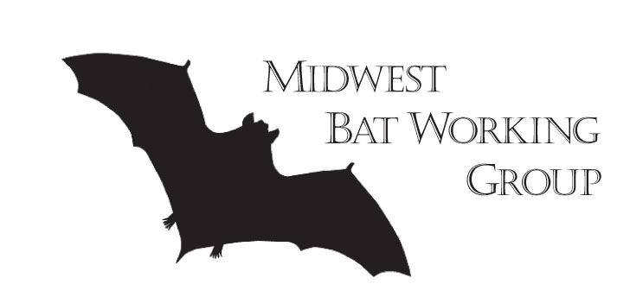
Meeting Announcement

9th Annual MIDWEST BAT WORKING GROUP Meeting

April 6-7, 2017
Meeting Host: Wisconsin DNR

LOCATION: Pyle Center, University of Wisconsin - Madison
702 Langdon St., Madison, WI 53706
http://conferencing.uwex.edu/location.cfm

Venue Contact: Bill Reed
bill.reed@ecc.uwex.edu
608-890-0849
Fax 608-265-0410

DUES AND REGISTRATION: deadline for registration is March 20, 2017, 5PM (CDT).
- Membership dues are $15 for students and $25 for professionals.
- Registration fee is $35 for students and $55 for professionals. After March 20th, registration fees go up $10; $45 for students and $65 for professionals.
- When paying your registration fee and/or dues, please complete the attached form (also available at http://www.mwbwg.org).
- If paying by check or money order, mail registration/dues form and payment to Brianne Walters, Department of Biology, Indiana State University, 600 Chestnut Street, Terre Haute, IN 47809. Checks should be made out to MWBWG.
- Payment by credit card (Visa or MasterCard) is accepted on-line using the instructions in the registration form.
  - If you pay on-line, please send the registration/dues form by postal mail or e-mail to Brianne Walters (brianne.walters@indstate.edu).

2017 MWBWG SILENT AUCTION:
- The Wisconsin planning team for the 2017 Midwest Bat Working Group annual meeting will be hosting a silent auction fundraiser that will run during the Poster Session and Social on Thursday, April 6th. Proceeds of the silent auction will be used to support state bat festivals or other bat conservation outreach events, and to support a student scholarship. Please let Brian Heeringa know by email (brian.heeringa@gmail.com) or call 715-292-5692 if you plan to donate an item for the silent auction. Please consider donating an item for this great fund-raising opportunity!

STUDENT/PROFESSIONAL MIXER:
- This is an opportunity for students members at lunch on Thursday to network and discuss careers with professionals in the field. Student pre-registration will be required (free). Professionals by invite only. Email Brian Heeringa (brian.heeringa@gmail.com) or Jennifer Redell (Jennifer.Redell@wisconsin.gov) by March 24th (Friday) to register. Students must be MWBWG members to attend the lunch.

LODGING:

- The Lowell Center is now completely booked. The Lowell Center is located 1 block from the Pyle Center at 610 Langdon St., Madison, WI 53703. (http://conferencing.uwex.edu/location.cfm).
- For your convenience we are offering one other hotel option at the Hampton Inn at Suites. The Hampton Inn is a 5-10 minute walk to the Pyle Center: https://goo.gl/maps/m3SGDkxuo1k There are a block of rooms reserved under the name “MWBWG”, which will be held until March 24th (Friday). Reservations may be made by calling the Hampton Inn & Suites Madison/Downtown direct at 608-255-0360 and mentioning the “MWBWG”. Cost is $139/per night plus tax. Parking fees for both nights have been waived. The rooms can be viewed here: http://hamptoninn.hilton.com/en/hp/groups/personalized/M/MSNBJHX-BAT-20170405/index.jhtml

TRAVEL:
- Driving Directions: For detailed directions to the Pyle Center, Lowell Center and parking, please see: http://conferencing.uwex.edu/location.cfm. For those not parking at the Lowell Center, public parking is available at the public State Street Campus garage two blocks away, at 415 N. Lake St. Madison, WI 53715. Cost to park at the garage is $1.30 per hour (http://www.cityofmadison.com/parkingutility/garagesLots/facilities/stateStCampus.cfm).
- Flights: The closest airport is the Dane County Regional Airport - MSN. See https://www.msnairport.com/ for more information.
- Airport to hotel transportation: Cabs await you at the airport and the Lowell Center can provide a $2/off coupon for your return to the airport.

MEALS:

- The Memorial Union is less than a block away at 800 Langdon St. and has several restaurants available for lunch: https://union.wisc.edu/visit/memorial-union/. There are also food cards on nearby Library Mall and many restaurants located on State Street a block away.
- In addition, there are many restaurants, local breweries, and even distilleries located in the downtown Madison area: http://www.visitmadison.com/restaurants/ and http://visitdowntownmadison.com/.

T-Shirts:

- T-shirts must be ordered by March 20th https://batconservation.org/shop/official-midwest-bat-working-group-2017-shirt/
PRELIMINARY SCHEDULE
(Subject to change)

Wednesday, April 5th
Early Bird Social - get together for those of you arriving the night before (Location TBD but likely local bar with good food and drinks)

Day 1 – Thursday, April 6th
8:00-10:00am – Registration and Breakfast
8:00-9:30am – Board of Directors Meeting (Block-O Room on Lower Level)
10:00am-10:10pm – Welcome
10:10am-11:10pm – Keynote: Curt Meine (Conservation Biologist, writer and Aldo Leopold Biographer.)
11:10am-12:30pm – Session
12:30-2:00pm – Lunch (on your own) – STUDENT-PROFESSIONAL MIXER (pre-registration required)
2:00-3:30pm – Session
3:30-3:45pm – Break
3:45-5:00pm – Session
5:30-8:30pm – Poster Session, Silent Auction, and Social (cash bar and heavy hors d’oeuvres)
9pm -'After-the-Social' Social (Location TBD but likely local bar with good food and craft beer)

Day 2 – Friday, April 7th
7:30-9:00am – Registration and Breakfast
9:00am-11:30pm – Session
11:30-1:00pm – Lunch
1:00-3:00pm – Session
*Note: This schedule is generalized and provided to help plan your travel. The final agenda will be available in late March after all abstracts have been received and processed.

Thank you! We look forward to seeing you in Madison, Wisconsin in April 2017!

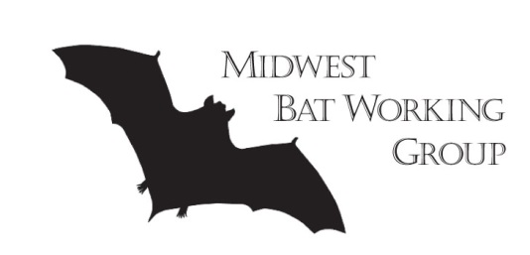
Registration/Dues Form
9th annual MIDWEST BAT WORKING GROUP Meeting
Pyle Center, University of Wisconsin – Madison, WI, April 6-7, 2017

Name (as you want it on your nametag):
Affiliation:
Address: |  |  |  |  | City, State, Zip:
Phone Number: |  |  |  |  | Email:

Are you willing to be a Student Oral Presentation Competition Judge? Yes _____ No _____
Are you willing to be a Student Poster Presentation Competition Judge? Yes _____ No _____
------------------------------------------------------------------------------------------------------------------------------------------
Payment Method (Check one) - Credit Card (online) _______ Check ________

Credit card payments online (nominal fee required) at:
Professionals: https://batconservation.org/shop/midwest-bat-working-group-annual-conference-professional-level/
Students: https://batconservation.org/shop/midwest-bat-working-group-annual-conference-student-level/
Make checks payable to MWBWG or Midwest Bat Working Group
Fee Type | Professional | Student | AMOUNT PAID
Registration (by March 15, 2017) | $55.00 | $35.00
MWBWG Annual Dues  (April 2017 – April 2018) | $25.00 | $15.00
Donation to Student Award Fund | Fill in any donation at right
TOTAL | Fill in TOTAL at right
Mail completed registration form and payment to:
Brianne Walters, Indiana State University, Dept of Biology, 600 Chestnut St., Terre Haute, IN 47809
(credit card payments: please e-mail registration information to brianne.walters@indstate.edu)

Thank you! We look forward to seeing you in Madison, Wisconsin in April 2017!

