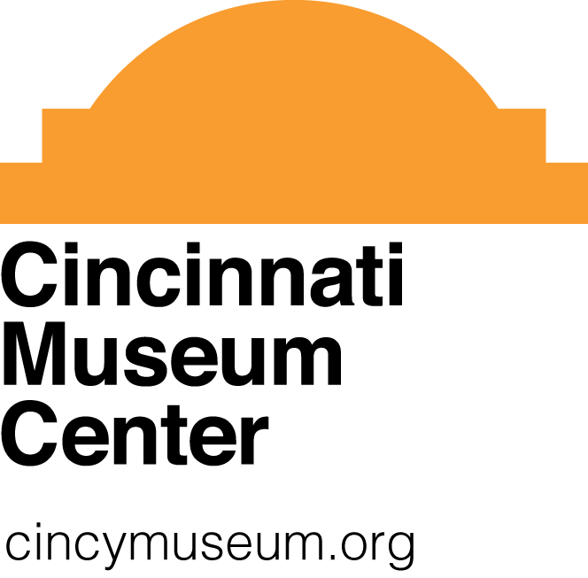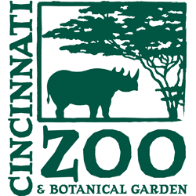

BatFest 2017 Registration Form

We invite your organization to participate in Cincinnati Museum Center’s BatFest at the Cincinnati Zoo and Botanical Garden on Saturday, April 1, 2017 from 10 a.m. to 4 p.m. To register your organization, visit cincymuseum.org/events/batfest or fill out the form below and return to Gwen Elliott at gelliott@cincymuseum.org by February 20, 2017.

Organization’s name and address: ____________________________________
_____________________________________
_____________________________________
_____________________________________

Contact for organization: _____________________________________________

Contact’s phone: _____________________________________________________

Contact’s email: _____________________________________________________

Brief description of intended presentation (including title if applicable):

Materials needed for Bat Fest:
- Table(s)
  - How many (up to 2 per registration): ______________
- Chairs (2 per registration)
- Electricity, available but limited (please be very specific on what you need)
- Other _________

Thank you for your participation in BatFest 2017!

You will receive a registration confirmation via email and additional information by February 28, 2017
With additional information to follow.

