Coil list and testing set-up

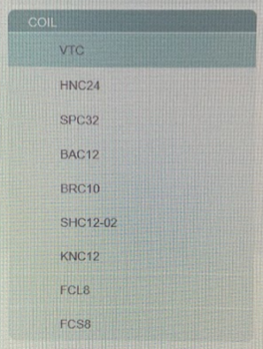
VTC: Volume transmit coil (body coil)
HNC24: Head and neck coil
SPC32: Spine coil
BAC12: Body anterior coil
BRC10: Breast coil
SHC12-02: Shoulder coil
KNC12: Knee coil
FCL8: Flex coil large
FCS8: Flex coil small

Special notes:
- When running scan, use standard SE acquisition. United uses TR=600ms, TE=15ms.
- To reconstruct images from individual coil elements, in the protocol set-up under System tab check the box “Uncombine” (this will reconstruct individual coil elements and a composite image)
- Turn off uniformity correction under the Recon tab (Uniform. Corr. = None; B1 is standard)

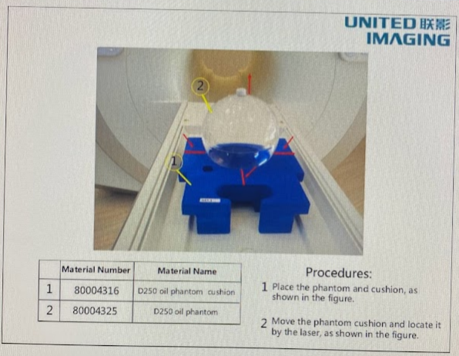
VTC (Volume transmit coil; body coil)

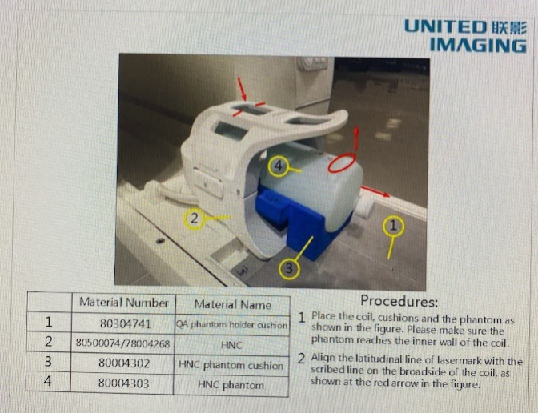
HNC24: Head & Neck Coil

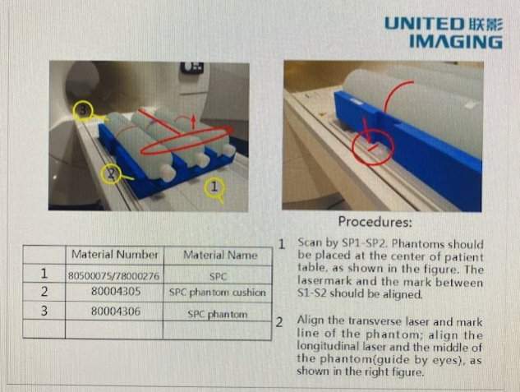
SPC32: Spine Coil

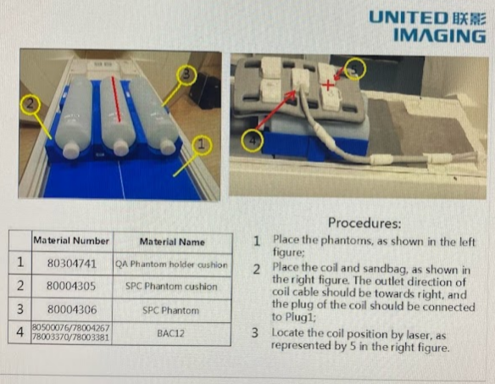
BAC12: Body anterior coil

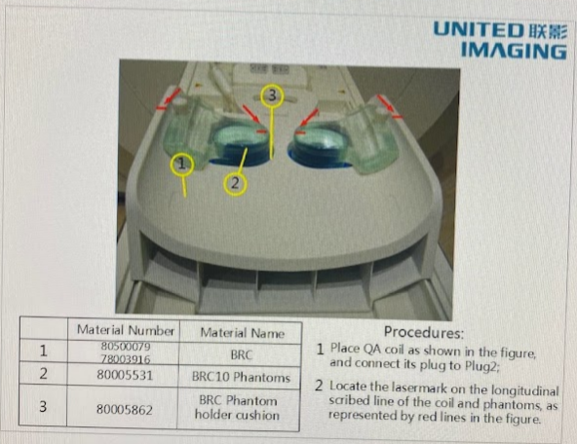
BRC10: Breast coil

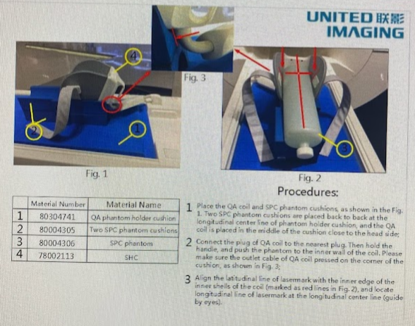
SHC12: Shoulder coil

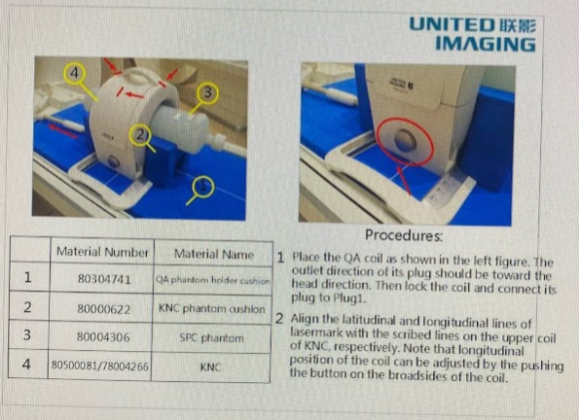
KNC12: Knee coil

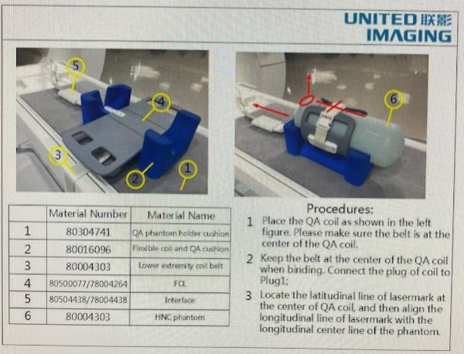
FCL8: Flex coil large

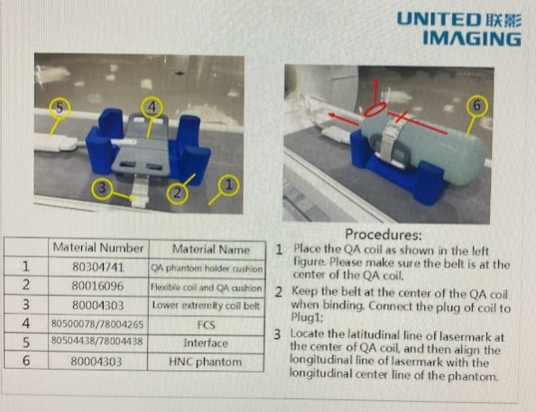
FCS8: Flex coil small

