Instructions to Submit a Comment on the Medicare and Medicaid Programs Proposed Rule
Deadline: September 15, 2025, at 11:59 PM
Topic: Medicare and Medicaid Programs: Hospital Outpatient Prospective Payment and Ambulatory Surgical Center Payment Systems; Quality Reporting Programs; Overall Hospital Quality Star Ratings; and Hospital Price Transparency
- Agency Centers for Medicare&Medicaid Services
- Posted Jul 17, 2025
- ID CMS-2025-0306-0002
Document: https://www.regulations.gov/docket/CMS-2025-0306/document

How to Submit Your Comment:
Visit the Comment Page:
Go to Regulations.gov Comment Page
Select Comment Category:
You can either directly comment in the box (we have four different sample texts for you to copy and paste from, see below), or attach a formal letter as a file. We have one sample letter from Dr. Cythia McCollough from Mayo Clinic (in a separate word document). Please feel free to edit to your own tyle, better with your official letter header.
Select Individual and specify your Role and Title in the comment to add credibility to your submission.
You can leave the selection blank for the answer “What is your comment about?”

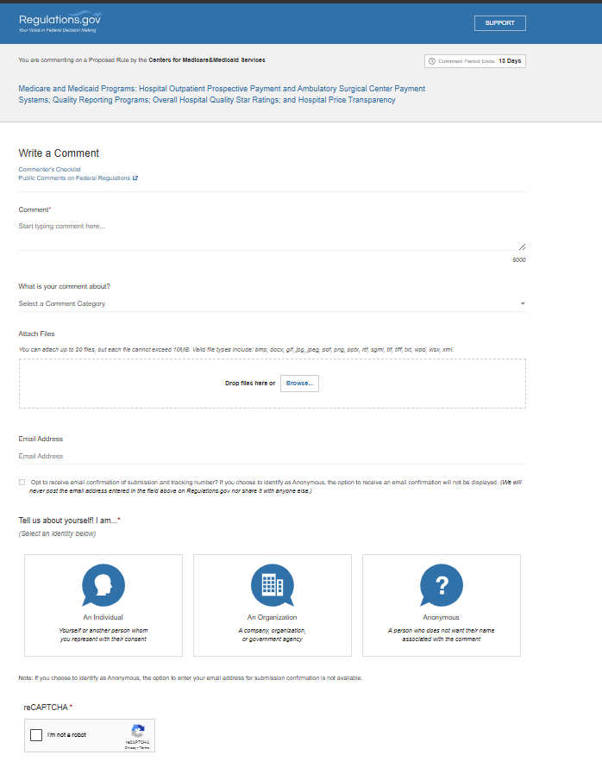

Draft Comment to Submit ():
Simple Version 1:
I am writing to comment on the proposed rules (CMS-1834-P) regarding the Hospital Outpatient Quality Reporting (OQR) Program, specifically on the proposed change to “Excessive Radiation Dose or Inadequate Image Quality for Diagnostic Computed Tomography (CT) in Adults” (CMS eCQM ID: CMS1074v1). I strongly support CMS’s proposal to make this quality measure voluntary in 2027 and beyond. The two major metrics in the eCQM, Calculated CT Global Noise and Calculated CT Size-Adjusted Dose, are fundamentally flawed. They do not reflect how radiologists assess image quality or how physicists measure and calculate radiation dose. They are inconsistent with some of the internationally recognized standards such as Size Specific Dose Estimate (SSDE). Enforcing fixed limits creates an untenable situation for some patient types that will lead to inferior diagnostic information and missed or incorrect diagnoses. Making the rule voluntary in 2027 and beyond will give time to professional organizations and CT imaging community to determine more valid metrics that truly monitor diagnostic quality and patient outcomes.

Simple Version 2:
This comment is regarding the proposed rules (CMS-1834-P), particularly on the proposed changes to the eCQM titled “Excessive Radiation Dose or Inadequate Image Quality for Diagnostic Computed Tomography (CT) in Adults” (CMS eCQM ID: CMS1074v1). I strongly support the proposal to make this rule voluntary at 2027 and beyond. The measure’s core metrics, “Calculated CT Global Noise” and “Calculated CT Size-Adjusted Dose”, have not received broad and strict validation in the clinical and scientific community. This measure relies on the use of a software tool that has been developed and is to be provided by a for-profit company, and that same company is the proponent of the measure. This is an inherent conflict of interest. Before the rule becomes mandatory, CMS should require independent studies, peer-reviewed evidence, and multiple implementation options. Making it voluntary in 2027 and beyond is the right thing to do.

Simple Version 3:
This comment is about CMS-1834-P and the recently proposed changes to eCQM CMS1074v1: Excessive Radiation Dose or Inadequate Image Quality for Diagnostic Computed Tomography (CT) in Adults. I strongly endorse the proposed change to make it voluntary in 2027 and beyond. The implementation in the original rule depends on ALARA Imaging, which is a new (2020), for-profit startup company with no track record of having previously performed any project on imaging, let alone a project of such wide scope, scientifically or technically. Sufficient time has not been allowed for testing with this company or for alternative companies to develop products that would allow a practice to comply with this measure. A voluntary period will allow careful further validation studies, fair competition among different commercial or academic tools, and simpler workflow before the rule becomes mandatory.

Simple Version 4:
I am writing to comment on CMS-1834-P and the recently proposed changes to eCQM CMS1074v1: Excessive Radiation Dose or Inadequate Image Quality for Diagnostic Computed Tomography (CT) in Adults. I strongly endorse the proposed change to make it voluntary in 2027 and beyond. Since the mandatory requirement imposes unnecessary regulatory burden and increase operational costs without corresponding improvements in patient care or system efficiency.
While the goal of improving transparency and quality in hospital outpatient and ambulatory surgical center payments is commendable, some provisions appear overly complex and administratively burdensome. These requirements could divert critical resources away from direct patient care and create additional compliance challenges for healthcare providers.
I urge regulators to carefully consider the cost-benefit balance of these requirements and explore opportunities to streamline reporting and documentation processes. Minimizing unnecessary regulatory burden is essential to fostering innovation, reducing administrative overhead, and ultimately improving healthcare delivery.

