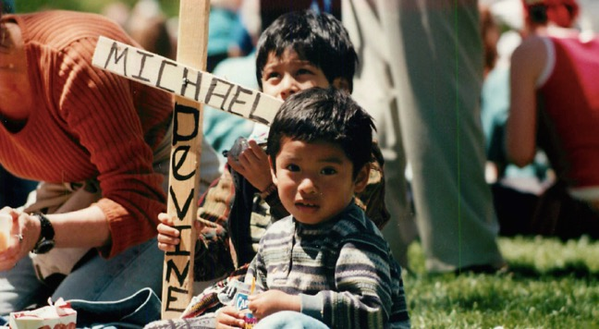

Explore the history, dominant discourses, and practices of aid (governmental and grassroots) to Central America by investigating primary texts dating from the nineteenth century to the present, by consulting the critical literature on the history of development, and by examining dramatizations in film and literature of both the predicaments of the region and solutions generated by residents and outsiders.  Throughout, we will attempt to understand why some humanitarian projects flourish whereas other, equally well-intended ones constitute setbacks rather than advances toward a more just, prosperous, and peaceful Central American reality.

# Comparative Studies 3501

# Humanitarianism in Question:

# U.S. Imperialism and Solidarity with Central America.

# Katherine Borland borland.19@osu.edu

For secondary color palettes please see: <http://brand.osu.edu/color/>

You can format color and enter the CMYK colors found there. Use darker colors for better legibility.

DEPARTMENT OF **COMPARATIVE STUDIES** SPRING 2017 | T/Th 11:10AM – 12:30PM | Stillman Hall 135