To: LC Policy and Standards Division, Joint Steering Committee for Development of RDA, Cooperative Program Section (Program for Cooperative Cataloging, Library of Congress)

From: Research Libraries, Archives, and Special Collections (RAS) Cataloging Committee, Association of Jewish Libraries

The Hebraica cataloging community has worked with RDA from the start of the US Official Test in the Fall of 2010 until the present time. We have attempted to ensure that RDA cataloging instructions and LC-PCC PSs can be applied successfully to resources in Hebrew script and to identify problems or issues that are not dealt with adequately in RDA and the Policy Statements.

We are most concerned with the impact of LC-PCC PS 6.2.2.10.3 on our ability to make useful catalog records for our rabbinical resources and the amount of time that it takes.

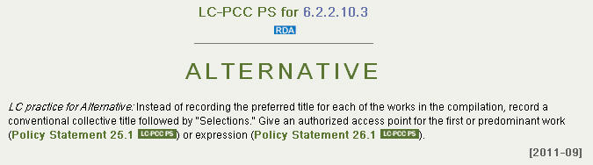

This policy was originally proposed by LC as a time-saving alternative to the basic instruction, which tells us make access points for every work in a compilation.  Following the basic instruction is the only way to truly tell the user what is in the compilation.  This alternative is supposed to give the cataloger a practical way to say "Okay, I can't really tell you everything" but "I do want to give you a heads up that I'm taking this short-cut.”

Most Jewish religious resources are compilations of various sorts. After working with a variety of rabbinic materials the RAS Cataloging Committee of the Association of Jewish Libraries came up with a list of English terms for rabbinic genres to be used as preferred titles for compilations of works by a single author, whether complete works in a single form or selections of works in a single form as prescribed in RDA 6.2.2.10.2 and 6.2.2.10.3.

|  |  |
| --- | --- |
| **Hebrew Term** | **Collective Uniform Title Term** |
| be’urim; he‘arot; he’arot; perushim | Commentaries. Selections |
| derashot | Sermons. Selections |
| devarim; liḳutim; peninim | Works. Selections |
| halakhot | Religious laws. Selections |
| ḥidushim | Novellae. Selections |
| ḳuntresim | Minor works. Selections |
| ma’amarim | Essays. Selections |
| mayśes̀; ertseylungn; sipurim | Anecdotes. Selections |
| pesaḳim | Decisions. Selections |
| she’elot/she’elot u-teshuvot; teshuvot | Responsa. Selections |
| shi‘urim | Lectures. Selections |

Many compilations describe themselves as including passages in several of these genres—and often it’s impossible for a non-specialist to detect which are intended to be which. Must these resources all be given the preferred title “Works. Selections”?

Supplying these titles and creating authority records for them represent a serious burden to Hebraica catalogers. Identifying the types to which these compilations of religious material belong is not an automatic process and requires a considerable knowledge of rabbinic writing traditions which not all Hebraica catalogers possess. Erroneous or idiosyncratic access points are sure to be created. Also, as more and more of these materials are written and received, catalogers identify new terms which need to be evaluated and added to the list. Handling conventional collective titles for these materials appropriately is simply impossible and the Hebraica cataloging community cannot afford to extend the list to all the possibilities that exist.

Catalogers everywhere are under pressure to produce the best cataloging records possible in the shortest amount of time. We cannot imagine a situation in which this practice would aid a patron in accomplishing the FRBR tasks in any degree commensurate with the effort we are making. We have asked RDA gurus to explain the value of the practice and have not yet received replies we could understand.

We, the representatives of the Hebraica and Judaica cataloging community would like to propose an exemption or simplification for Hebraica rabbinic resources in LC-PCC PS 6.2.2.10.3 for these “compilations” by a “single author.”

Thank you,

Association of Jewish Libraries, RAS Cataloging Committee (Heidi G. Lerner, Chair)