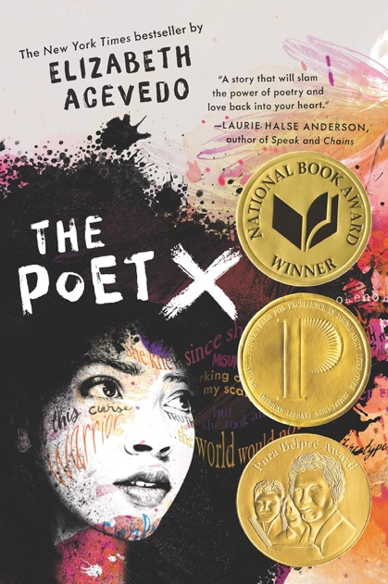

Introduction to Latinx Literatures and Cultures
ENGLISH 4588 & COMPSTD 4804
Spring 2024
TuTh 9:35AM - 10:55AM
Dr. Mintzi Auanda Martínez-Rivera
Contact information: martinez-rivera.2@osu.edu

Through the study of oral narratives (such as legends, corridos, and wordplay), novels (including Children and YA novels), poetry, short stories, musicals, and films, this course offers a broad introduction to the study of U.S. Latinx Literature and Culture. Moving among and away from the canon, we will explore issues of race and ethnicity, citizenship and belonging, ideologies of gender and sexuality, revolution, and social movements, growing up in the U.S., among other topics, as they relate to the experience of Latinx communities living in the U.S. Through different assignments, students will have the opportunity to investigate a topic of their choice and create their own (non)creative project.

