Pagan to Christian:
Religious change in early medieval Ireland 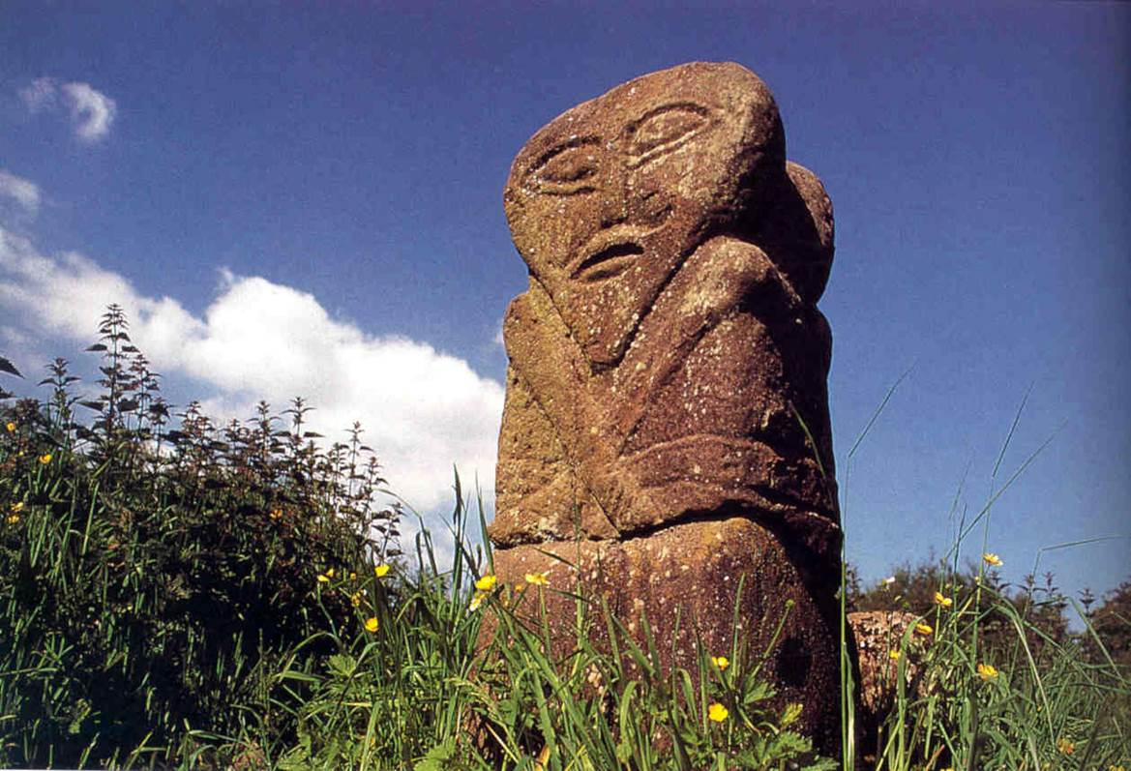

Dr. John Soderberg
Dennison University

Wednesday, November 16, 2016 8 PM
Koffolt Lab, 140 W 19th Ave, Room 207 OSU Campus

Fanciful ideas about mediaeval Ireland having preserves for pagan Celts or refuges for Christians saving European civilization have long dominated our understanding. The construction boom of the early 2000s produced a trove of archaeological information that is transforming views of what existed before the emergence of Christianity and how the process of conversion played out. This talk will survey new views of religion in medieval Ireland and consider what we learn about the dynamics of religious change.
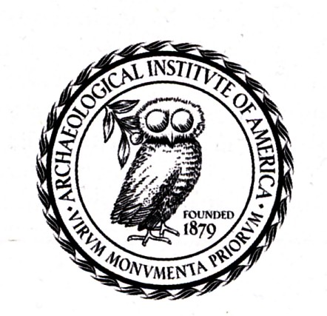
Archaeological Institute
of America
Columbus Society

