**Bio**

Juan Manuel Restrepo-Flórez is a post-doctoral associate at the University of Wisconsin–Madison. Before accepting his position in Madison, he was a Ph.D. candidate at the Georgia Institute of Technology. He holds a bachelor’s degree in biological engineering from the National University of Colombia and a master’s degree in chemical and biochemical engineering from the University of Western Ontario.

The William G. Lowrie Department of Chemical and Biomolecular Engineering

Cordially invites you to attend a seminar on

**A Road Toward Sustainability – From Materials to Processes**

Praesent mauris ante fewda getrw

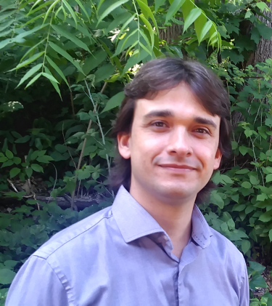

**Abstract**

Industrial processes and transportation account for more than 70% of the United States energy consumption. Finding strategies to either reduce energy consumption or to enable the use of renewables in these sectors may prove instrumental in the context of sustainability. To achieve this vision innovations from the material to the process scale are needed.

At the industrial level, the need for energy-efficient separations is one of the main innovation drivers, provided that (1) they account for more than 50% of the energy consumption in the sector and (2) they are dominated by thermally driven processes. In this context, membranes appear as attractive alternatives. Understanding the different physical processes underlying these separation operations is important to develop new applications. In the first part of this talk, I will discuss how mass diffusion metamaterials theory can be used to engineer new membranes capable of performing separations by controlling independently the *flux direction* of different components. This is in contrast, to typical membranes that operate by controlling the *flux magnitude*.

In the transportation sector, the need to find sustainable alternatives for middle distillates (diesel and jet fuel) is imperative, these fuels are consumed in sectors whose electrification is more challenging. In the second part of this talk, I will present a systematic approach to the design of advanced biofuels. The approach that I will describe integrates into a single framework the design of chemical processes and fuels with tailored properties. Thus, opening the door to the production of biofuels that are superior to their fossil counterparts. In particular, I will show how this approach can be applied to the upgrading of ethanol into diesel and jet fuel, and I will address three fundamental questions: (1) What are the energy requirements associated with the production of middle distillates? (2) What is the interplay among fuel properties, economics, and processes? and (3) What is the ability of the advanced fuels identified in this work to satisfy fuel demand and mitigate CO2 emissions?

Please click the link below to join the webinar:

<https://osu.zoom.us/j/91352766618?pwd=OEtVY2Z5QkwvalR5N1d2ZnZNODlNZz09>

Password: 875861

**Juan Manuel Restrepo-Florez**

*Postdoctoral Associate*

*Chemical Engineering University of Wisconsin-Madison*

**Thursday, March 3**

**11:30 AM**

**Virtual Seminar**