**Abstract**

High-energy density batteries will play a remarkable role in hurdling global climate change. My research focuses on the fundamental understandings of their electrochemical reaction mechanisms and the design of materials, protocols, and characterization tools to enable their safe operations over long-term use. First, I will discuss about the previously overlooked dynamics of detached lithium metal filaments during battery operations. This discovery leads to the recovery of lost capacities in lithium-metal batteries and enables fast charging in lithium-ion batteries. Next, I will introduce a characterization tool for the on-board monitoring of battery health based on pressure evolutions. In addition to capturing the early signs of battery failure, this pressure sensing system offers new insights into the battery degradation process. Overall, the combination of fundamental study and the rational design of materials/protocols/characterization tools opens broad opportunities toward a clean energy future.

The William G. Lowrie Department of Chemical and Biomolecular Engineering

Cordially invites you to attend a seminar on

**Revealing the Unknown Dynamics of High-Energy-Density Lithium-Metal Batteries**

Praesent mauris ante fewda getrw

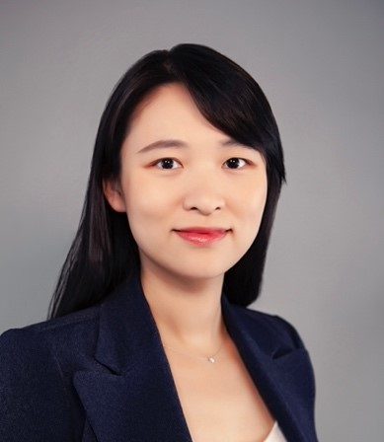

**Bio**

Dr. Fang Liu received her Ph.D. degree in Chemical Engineering from the University of California, Los Angeles, under the guidance of Prof. Yunfeng Lu. During her graduate study, she developed a series of functional materials and cell architectures to advance the high-energy-density sulfur cathode. In 2019, she started her postdoc training at Stanford University, working with Prof. Yi Cui in Materials Science and Engineering. Her research centers around the fundamental understandings of the electrochemical reaction mechanisms to enable the safe operation of lithium-metal batteries and lithium-ion batteries under fast charging conditions. She receives several honors and awards, including the Electrochemical Society (ECS) Young Investigator Lecture Series in the San Francisco section, Women Chemist Committee Postdoc Series at University of Illinois at Urbana-Champaign, ARCO Fellowship, UCLA Dissertation Year Fellowship, and UCLA Graduate Division Fellowship. She is the lead organizer of the broader impact symposium "Women in Materials Science" at Materials Research Society Fall Meeting (2021) and an active member of Stanford Allies for Women in Science and Engineering (WISE) Group MatSci DEI Task Force and MatSci Mentors Program.

Please click the link below to join the webinar:

<https://osu.zoom.us/j/97031566957?pwd=K05JWFhtY0NsMWIxWUE3TVN3blBWdz09>

Password: 684429

**Fang Liu**

*Postdoc Research Fellow*

*Department of Materials Science & Engineering*

*Stanford University*

**Tuesday, March 8**

**11:30 AM**

**Virtual Seminar**