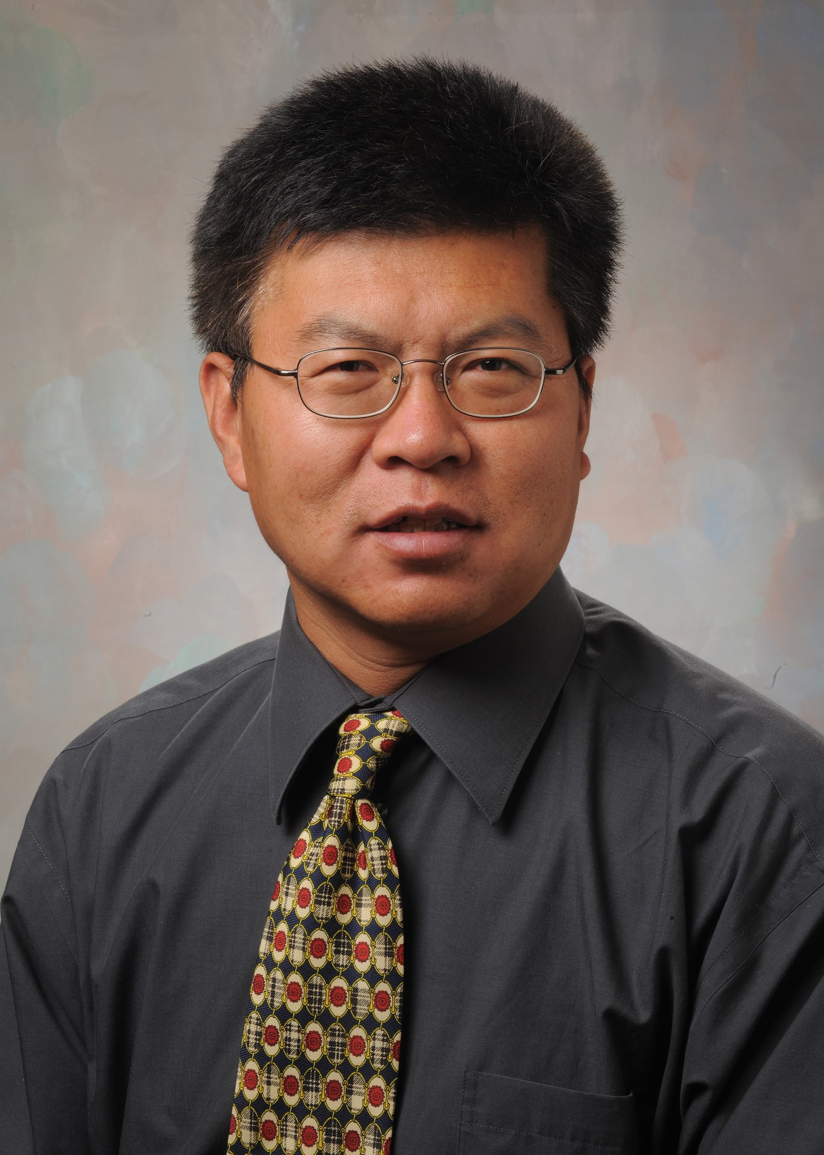

The William G. Lowrie Department of Chemical and Biomolecular Engineering

Cordially invites you to attend a seminar on

**Novel Electronic Materials for Energy Generation and Storage**

Praesent mauris ante fewda getrw

**Bio**

Currently, Dr. Xiong Gong is a Professor of Polymer Engineering in the School of Polymer Science and Polymer Engineering at The University of Akron (UA). He also holds a joint position as a Professor in the Department of Chemical, Biomolecular and Corrosion Engineering at UA. Before that, he was a manager and senior scientist at CBRITE Inc. and a senior research scientist in the Center of Polymers and Organic Solids at the University of California Santa Barbara (UCSB). Dr. Xiong Gong received B. Sc. in Chemistry, M. Sc. in Materials Science, and Ph. D. in Physics. He did a post-doc fellowship with Professor Alan Heeger (a [Nobel Prize Laureate](https://en.wikipedia.org/wiki/Nobel_Prize_laureate)) at UCSB. Dr. Gong has accomplished over 237 articles published in peer-reviewed journals, with a peer citation ~ 26,400 times. He earned an H-index of 70. He also contributed 32 granted patents and 5 pending patents, and 8 book chapters. Dr. Gong received many international and national awards and honors including the world's most influential scientific minds, the top 1% most cited researchers by Thomson Reuters, the National Science Foundation Career Award, Outstanding Research Award at UA. He currently serves as an associate editor for Organic Electronics and Emergent Materials, and Editorial Board Members for a couple of scientific journals.

Please click the link below to join the webinar:

<https://osu.zoom.us/j/97579889819?pwd=ZmljVnJxcnkxVUo2eHRwdkc1T3NUQT09>

Password: 398221

**Abstract**

Solution-processed electronics for efficiently and economically harvesting and storing renewable energy have invoked extraordinary attention in both academic and industrial sectors in the past years. In this talk, I will share with you our studies on novel electronic materials for energy generation and storage. Firstly, I will present the development of high-performance perovskite solar cells via novel hybrid inorganic-organic perovskites, novel device architectures, and device engineering. Secondly, I will describe the fabrication of flexible all-solid-state supercapacitors. In the last part of my presentation, I will share with you the development of wireless portable light-weight self-charging power packs/electronics.

**Xiong Gong**

*Professor*

*School of Polymer Science & Polymer Engineering*

*University of Akron*

**Thursday, February 24, 11:30 AM**

**Virtual Webinar**