**Zeolite Materials as Valuable Catalyst Components in Chemical Processes and the Role of Organ-Cations in Shaping Synthesis Outcomes**

In this presentation I will briefly survey some of the valuable contributions that zeolites have made in developing catalysts for chemical technology. One comparison we can make is that while there a period of time where zeolite manufacturers worked to modify the properties of 5 zeolite structures, where there was good commercial synthesis experience for these 5, the terrain is now such that more than 20 different zeolite structures are in commercial use. The driver for these advances is that a given new zeolite can simply deliver better performance than what was known before. An integral part of the zeolite structure discovery advance has been the use of organo-cations in the synthesis, serving as components around which silica-rich zeolites grow. We will examine some of the reaction dynamics in that process. Then I will discuss how the use of boron in the high silica zeolites allows for (a) a chance to find new structures and (b) the engineering of catalytic sites in a growing zeolite.

**Stacey I. Zones**

sizo@chevron.com

Chevron Energy Technology Company, Richmond, CA

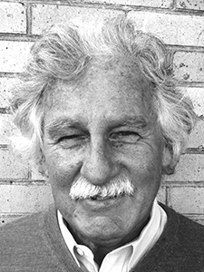Stacey I. Zones is currently a Research Fellow with Chevron’s Energy and Technology Company, working in the catalyst department. He has also been an Adjunct Professor in Chemical Engineering at the University of California, Berkeley, Department of Biological and Chemical Engineering. Dr. Zones earned a Ph.D. in Inorganic Chemistry from the University of California at San Diego in 1978. He joined Chevron in 1980 and began a program in searching for new zeolite structures with a strong emphasis on designing organic cations to aid in the synthesis. He continues to head that effort for Chevron, as well as contribute as a team member in efforts to develop the zeolite products into commercial use, working on manufacturing and catalyst development efforts. He is also involved in new business opportunities.

Dr. Zones is a co-author and co-inventor on more than 170 zeolite science papers and 180 technology patent applications. His research was recognized by the International Zeolite Association with the 2001 Breck Award for outstanding research contributions, and Houdry Award from the North American Catalysis Society in 2007 for contributions in applied catalysis. In 2014, he was elected to the United States National Academy of Engineering. Most recently he was honored with the Catalysis and Reaction Engineering Division (CRE) Practice Award from AIChE in 2016.