2020 September Virtual Seminar
November 10, 2020
11:00 am – 12:30 am
From the convenience of your foundry office

Foundries, please join us for a practical 1.5 hr. VIRTUAL seminar on 3D Printing in Production Applications. The presenter will be Mr. Brandon Lamoncha, Director of Additive Manufacturing at Humtown Products. Brandon and Humtown have recently been awarded 2020 Manufacturer of the Year by the National Association of Manufacturers as well as High Achiever Award in Engineering and Production Technology Leadership.
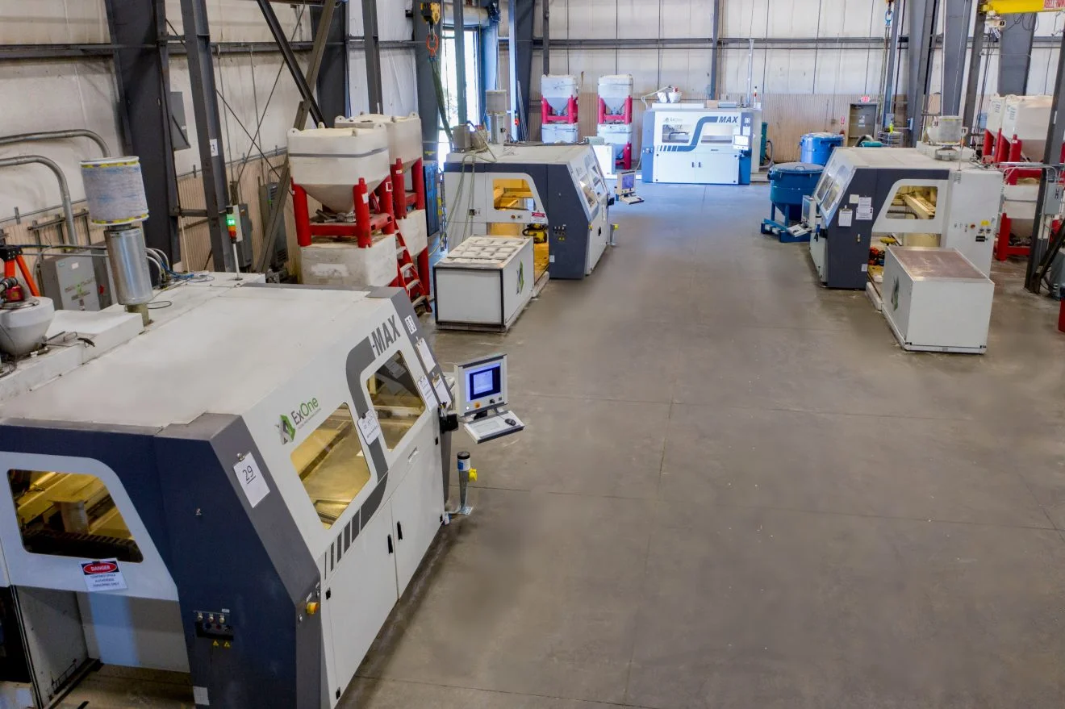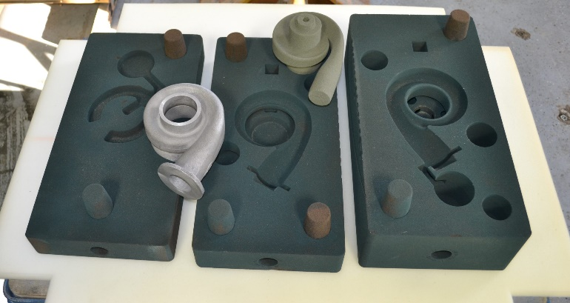
Humtown has been a pioneer in additive manufacturing and Brandon has been leading the way in 3D printed sand cores and molds. This seminar will amaze you with new technology and the endless possibilities of 3D printing.
We are inviting all foundries including ferrous and nonferrous. Sand technology is as critical as metal technology.
There will be no cost for this event. Please register at https://www.eventbrite.com/e/3d-printing-in-production-applications-tickets-126967245449 A link will be sent to your e-mail the day before the event.
Any questions or concerns that you can share regarding 3D Printing prior to this date, will give Brandon a chance to address it during the Q&A session. Please send any email correspondence to mjwarner@keenersand.com
Thank you for your consideration and your continued support of AFS Central Ohio Chapter.

