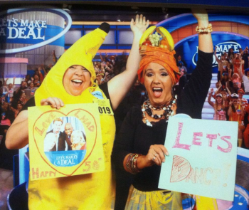
AFS CENTRAL OHIO CHAPTER
SCHOLARSHIP FUNDRAISER

AFS-COC PRESENTS

“LET’S MAKE A DEAL”

When: Saturday, February 15, 2020
Where: Makoy Center – 5462 Center St.
Hilliard, OH. 43026
Phone: (614) 777-1211
Reception: 6:30 pm
Dinner: 7:30 pm
9 to 11:30 Music, Dancing, Reverse Lotto, and more…
Dress Casual or Party Theme attire to play and win!!

Make your reservations now by filling out the bottom portion and returning it with your check.
Make checks payable to: AFS Central Ohio Chapter and mail to:
Mike Warner
Keener Sand & Clay Company
330 Dering Avenue
Columbus, OH. 43207

Reservation Deadline: January 29, 2019
Includes: Beef Short Rib or Salmon Dinner, Prizes, Open Bar and lots of fun!!
**Hampton Inn Hilliard 614-334-1800, 10 rooms have been blocked @ $105.00 +tax/Night***
1/29/19 is the cut off for the above rate
Call the hotel directly to set up your reservation and tell them you are with the AFS Winter Party

Please reserve _____ tickets, at $145 each-per couple, for the Winter Party, to be held at the Makoy Center in Hilliard on Saturday, February 15, 2019.
Enclosed is my check for $______________
Note: Tickets can be picked up at the time of the reception. Please list names of couples and preferred meals.
Names:____________________________________________________________________________________
Meals: Beef Short Rib_____; Salmon_____; Dietary Meal_____

